ARDUINO BASED

RESISTANCE AND CAPACITANCE

MEASUREMENT MODULE

Objectives:
1)Fundamental concepts like ohm’s law, voltage division, RC time constants are used to build the circuits in the below tasks.
2)In the process of solving the tasks one can understand the internal design of multimeter i.e simplified resistance and capacitance measurement modules using Arduino uno.
3) To learn the use of Arduino’s Analog-to-Digital Converter (ADC) for converting real-world analog voltages into digital values that can be processed by software.
4) To design and simulate basic measurement blocks (voltmeter, ohmmeter, capacitance meter) using Tinkercad Circuits.
5) To analyze measurement accuracy and errors by comparing theoretical values with simulated (measured) results.
6)one can also develop documentation skills and reporting skills.

Theory:

Voltage Divider Principle:
A voltage divider is a simple circuit formed by two resistors connected in series across a voltage source. The output voltage is taken from the junction of the two resistors.
Voltage Divider Equation
$$V_{out}=V_{in}×\frac{R_{2}}{R_{1}+R_{2}}$$
ADC Conversion Theory:
The Arduino Uno uses a 10-bit ADC, producing values from 0 to 1023.
$$V_{measured}=\text{ADC value}×\frac{V_{ref}}{1023}$$
Where:
- $V_{ref}=5V$(default reference)
- ADC value is from analogRead()
Resistance Measurement Using Voltage Divider:
In a basic ohmmeter:
- A known reference resistor (Rref) is connected in series with an unknown resistor (R_{x}).
- The midpoint voltage is measured using the Arduino ADC.
Resistance Calculation Formula
$$R_{x}=R_{ref}×\frac{V_{out}}{V_{in}-V_{out}}$$
Working Principle
- Different resistance values change the voltage division ratio.
- The Arduino calculates Rx based on the measured voltage.
- This principle is identical to resistance measurement in digital multimeters.
RC Time Constant and Capacitance Measurement :
An RC circuit consists of a resistor (R) and capacitor (C) connected in series.
RC Charging Equation
$$V(t)=V_{max}(1-e^{-t/RC})$$
At time $t=RC$:
$$V(t)=0.63×V_{max}$$
This point is called the time constant (τ).
Why 63% Is Important
- At one time constant, the capacitor reaches 63% of its final voltage.
- This property allows capacitance to be calculated by measuring time.
Capacitance Calculation
$$C=\frac{t}{R}$$
Where:
- $t$= time to reach 63% of supply voltage
- $R$= known resistor value
Role of Arduino
- Arduino charges the capacitor through a resistor.
- analogRead() monitors capacitor voltage.
- millis() or micros() measures charging time.

TASK- A CIRCUIT:
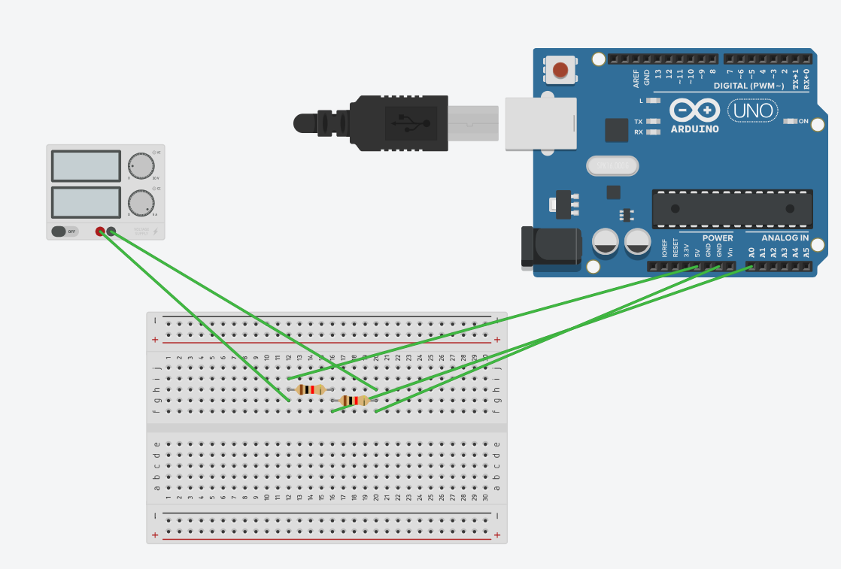
const int analogPin = A0;
const float R1 = 1000.0; // R1 ,R2 are resistances of used resistors
const float R2 = 15000.0;
const float Vref = 5.0; Reference voltage
void setup() {
Serial.begin(9600);
}
void loop() {
int adcValue = analogRead(analogPin);
float Vout = (adcValue * Vref) / 1023.0;
float Vin = Vout * (R1 + R2) / R2;
Serial.print("ADC Value: ");
Serial.print(adcValue);
Serial.print(" | Vout: ");
Serial.print(Vout, 2);
Serial.print(" V");

Serial.print(" | Vin: ");
Serial.print(Vin, 2);
Serial.println(" V");
delay(1000);
}
RESULTS:
v_{in =} 5 v
Formula:
$$V_{out}=V_{in}×\frac{R_{2}}{R_{1}+R_{2}}$$
R1 | R2 | THEREOTICAL (vout) | EXPERIMENTAL (vout)
10Kohm | 10kohm | 2.5 v | 2.5 V
4.7kohm | 10kohm | 3.41 v | 3.4 V
1 kohm | 15ohm | 4.68 v | 4.69 V

TASK B CIRCUIT:
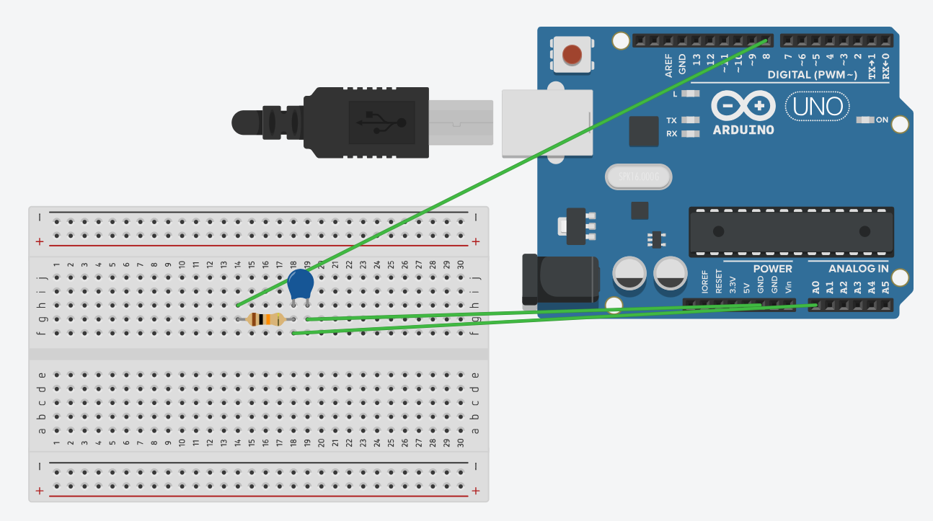
const int chargePin = 8;
const int analogPin = A0;
const float R = 10000.0; // 10kΩ resistor
const int threshold = 648; // ~63% of 1023
void setup() {
Serial.begin(9600);
}
void loop() {
pinMode(chargePin, OUTPUT);
digitalWrite(chargePin, LOW);
delay(5000); // FULL discharge (important!)
pinMode(chargePin, INPUT); // isolate pin
delay(100);
pinMode(chargePin, OUTPUT);
digitalWrite(chargePin, HIGH);
unsigned long startTime = micros();
while (analogRead(analogPin) < threshold) {
// wait until 63%
}
unsigned long elapsedTime = micros() - startTime;
float timeSeconds = elapsedTime / 1000000.0;
float capacitance = timeSeconds / R;
Serial.print("Time (s): ");
Serial.print(timeSeconds, 3);
Serial.print(" Capacitance (F): ");
Serial.println(capacitance, 6);
delay(3000);
}
RESULTS:
CAPACITANCE | THEORETICAL | EXPERIMENTAL
10 (MICRO F) | 1 s | 1.000
100 (MICRO F) | 0.1 s | 0.1000

TASK C CIRCUIT:
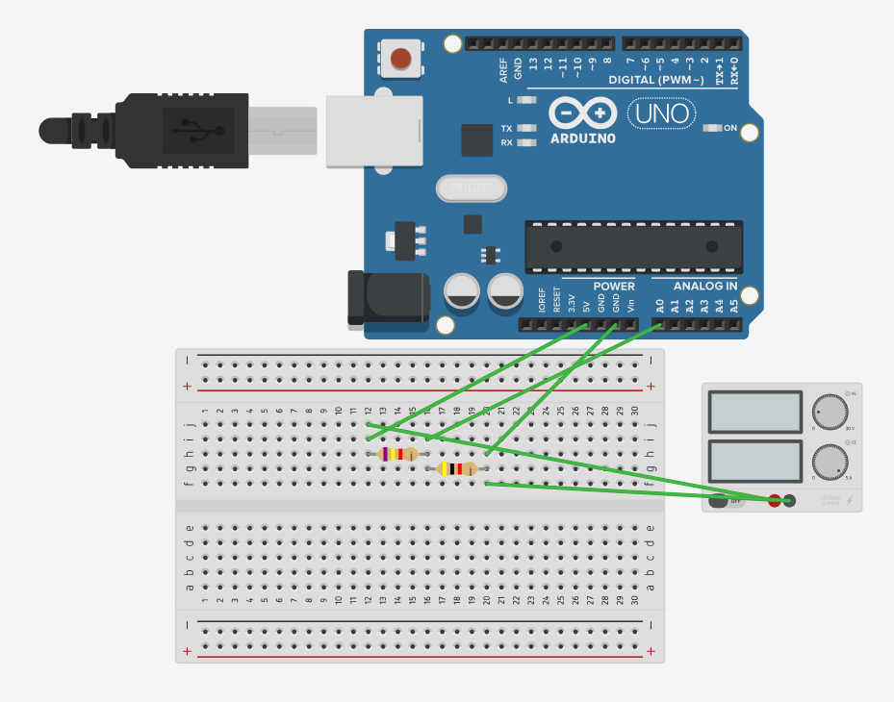
const int analogPin = A0;
const float Vin = 5.0; // Arduino supply voltage
const float Rref = 7400.0; // 4.7kΩ reference resistor
void setup() {
Serial.begin(9600);
}
void loop() {
int adcValue = analogRead(analogPin);
float Vout = Vin * adcValue / 1023.0;
float Rx = Rref * (Vout / (Vin - Vout));
Serial.print("ADC: ");
Serial.print(adcValue);
Serial.print(" | Vout: ");
Serial.print(Vout, 3);
Serial.print(" V | Rx: ");
Serial.print(Rx);
Serial.println(" ohms");
delay(1000);
}
RESULTS:
Rref:7400 ohm
Vin: 5v
Formula:
$$R_{x}=R_{ref}×\frac{V_{out}}{V_{in}-V_{out}}$$
$$V_{OUT}=\text{ADC value}×\frac{V_{IN}}{1023}$$

Rx (UNKNOWN) GIVEN | Rx(unknown) obtained | ADC | Vout(experimental) | Vout(thereotical)
56 kohm | 56215.13 ohm | 904 | 4.418 v | 4.4183 V
4 kohm | 4000.90 ohm | 359 | 1.755 v | 1.754 V
32 kohm | 32028.12 ohm | 831 | 4.062 v | 4.061 V

LEARNING OUTCOMES:
- Applied Ohm’s Law and voltage divider principles to design practical measurement circuits.
- Understood the role of resistors and capacitors in electrical measurement systems.
- Gained a bit of experience with the Arduino Uno’s 10-bit ADC for analog-to-digital conversion.
- Implemented voltage, resistance, and capacitance measurement modules similar to those used in digital multimeters.
- Demonstrated the concept of RC time constant and its use in capacitance measurement.
- Compared theoretical calculations with simulated results to identify measurement errors and uncertainties.
- Developed skills in circuit simulation, data observation, and technical documentation using Tinkercad.
CONCLUSION:
This assignment helped in understanding how basic electrical concepts are used in real measurement systems. By designing and simulating voltage divider, ohmmeter, and RC-based capacitance measurement circuits using the Arduino Uno, important ideas like Ohm’s Law, ADC conversion, and time constant were clearly understood. Comparing calculated values with measured values showed how factors such as component tolerance, ADC resolution, and noise affect measurement accuracy. Overall, this project gave a clear idea of how digital multimeters work and built a strong foundation for learning advanced smart instruments and embedded measurement systems.

